IMMC 2021 Summary Sheet
Team Control Number: 21585084

The development of astronomy has allowed us to launch multiple devices into the space, and to allow human beings to stand on moon. Based on the current technology, the scientists claimed that it was possible for to start a design into print in 3D of a closed shelter on the Moon allowing astronomers to work and live.
Our team generally aims for to have the most productive construction at the lowest possible cost and the least amount of time, and to make it comfort a safe area for astronomers to live. The productivity of the shelter depends on various different factors, of which are suggested but not limited to the rarity of the material, the size of the designed excavation part, and the geography environment, et cetera. If the material used to build the shelter was considered rare, then too much time was wasted on searching for the mineral. Another factor is the geographic surroundings of the moon, many meteorites will land on Moon providing a crater, this might threat the lives of astronomers. Other minor factors such as quality of construction can also play apart.
The shelter’s safety also depends on many factors: size, wall, shape, not mentioning many. The temperature of the moon could be as low as approximately -190 Celsius, and could be as around high as 130 Celsius. At any condition, a human being will be hard to survive without a satisfactory insulator for heat. The sturdiness of the architecture is also highly dependent on the design of the shape submitted, the base of the shelter, only mentioning a few.
This paper, we will be attempting to design a closed shelter space to determine the best living area for the 20 astronauts based on these criteria. Obviously, it would be difficult to accommodate all of these factors. As a result, we will only be considering three key factors.
First, we will consider the geometric shape of the closed space. Our group’s design is a spherical crown with a cylinder underneath as the base of support. Then, we will consider the thickness and material of the wall for the astronomers’ shelter in order to keep in the heat. Finally, the size of the construction will be set, including how big the shelter is, and how deep the base is in the design.
This shelter will be built according to these three factors, and the result reported.
Contents
I. Summary 1
II. Introduction 3
III. Defining the problem 3
3.1 Question restatement 3
3.2 Assumptions 3
3.3 Variables 5
IV. The Design of the Shelter 6
4.1 Overview 6
4.2 Selecting the Shape of the Shelter 7
4.3 Selecting the Dimensions of the Shelter 7
4.4 Selecting the thickness of the wall 8
4.5 Summary 9
V. Strengths 10
VI. Weakness 11
VII. Conclusion 11
VIII. Appendix 12
8.1 Python: 12
8.2 Matlab: 13

II. Introduction
Planning a closed shelter on the moon is a difficult job, it has complicated but essential requirements that differ from building a shelter on Earth. Problems anticipated in the construction include geographic shape of the shelter, which should be constructed by the least amount of material, but also enabling the largest amount of space. Another problem is the size of the station, and that is affected by the cost and work of the product being made. Furthermore, the problem includes the thickness of the wall of the shelter that may have interactions with the environment outside the construction. Lastly, to ensure stability of the shelter, it will be divided into 2 parts: above ground and underground
To locate an appropriate venue of the closed shelter for the astronauts, an algorithm is to be designed to determine some key factors and filter out the best decisions. The shelter must be closely aligned to the data available to the algorithm, while at the same time having the flexibility to minimum the cost and time and to maximum the productivity.
Before explaining the construction of the shelter, we will begin first by defining the problem.

III. Defining the problem

3.1 Question restatement

This question requires us to:
1. Create a closed shelter space that allows astronauts the best places to work and rest on the moon’s surface, in which has the capacity of 20 astronauts, and to only use the ray material on the lunar surface.
2. Use 3D printing to print the completed design.
Given these objectives, we can begin laying out the assumptions and variables we need to account for and define.

3.2 Assumptions

In designing our model, we decided on several basic assumptions. Listed below are the assumptions and our justifications for them.
Assumption 1: 350 cubic meter of interior space is required for the shelter.
Justification: we cannot fully acquaint the interior space necessary for the station, so we roughly estimate that 350 cubic meter is enough for 20 people
Assumption 2: The shelter will be divided into 2 parts: above ground and underground
Justification: to ensure stability of the shelter, it needs an underground base of support
Assumption 3: The underground part of the shelter is at least 2m thick.
Justification: The underground part of the shelter provides a base of support for the entire shelter, therefore it possesses certain thickness, and if you want to reduce the expenditure, the underground part needs to be as shallow as possible.

3.3 Variables

Variable Name | Definition
R | Radius of the sphere the spherical crown shaped part (above ground part) is located
H | Height of spherical crown (half of R)
h | Height of cylinder
$$\frac{∂T}{∂x}$$ | Temperature gradient of thermal conduct from the exterior of the shelter towards interior of the shelter
$$k_{x}$$ | Thermal conductivity in the direction x (from the exterior of the shelter towards interior of the shelter)
$$J_{T}$$ | Thermal flux in the direction from the exterior of the shelter towards interior of the shelter (in W/$m^{2}$)
$$R_{1}$$ | Radius of maximum opening at the bottom of the spherical crown
θ | Degree of angle between the line segment from the center of the sphere where the spherical crown is to the edge of the bottom of the spherical crown and the line segment from center of the sphere to the height of the spherical crown

IV. The Design of the Shelter

4.1 Overview
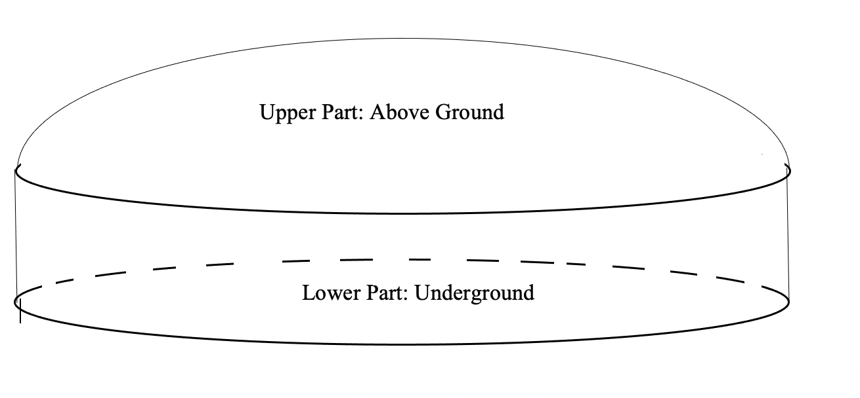
Overall, the base is a spherical crown above the ground and a cylinder part underground. This is a model overall, considering all three aspects: sturdiness, thermal insulation, and expenditure, the most commendatory plan of building the shelter. The spherical crown shape can disperse part of the pressure applied to the base. The vacuum design of the interlayer between thick can completely insulate heat and chill from outside, and lastly assuming all the space inside can be occupied and not considering transportation in and out of the base, this design, although not the most economical, demands a relatively low expenditure.

4.2 Selecting the Shape of the Shelter
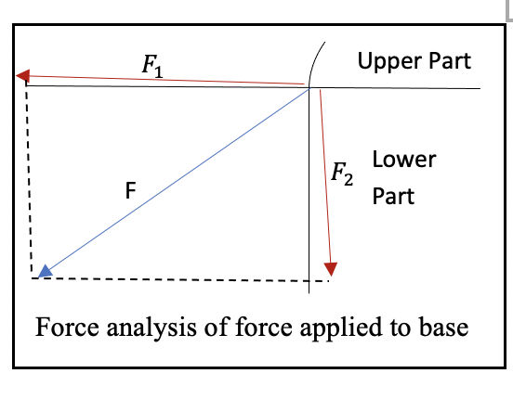
The whole shelter is consisted of two parts: the spherical crown above the ground and the cylinder underneath. The reason why we choose such shape is because it gives consideration to both sturdiness and economic efficiency.
The spherical crown shape allows the upper part apply force in the diagonal direction which under this circumstance, the force is dispersed into 2 forces, as shown in the diagram to the right. Here, the force F, shown with the blue arrow, is distributed into 2 forces, $F_{1}$ and $F_{2}$, shown with the red arrows. Eventually, only $F_{2}$ is applied the base of support, and stabilizes the entire structure. Also, the cylindrical structure underneath demonstrates more effective performances in coping with surrounding stress than other shapes while maintaining a relatively low expenditure. These reasons explained above are the reasons we choose this structure.

4.3 Selecting the Dimensions of the Shelter

Acknowledging the total volume of the interior, we can define R to be the radius of the sphere the spherical crown shaped part (above ground part) is located, H to be height of the spherical crown, h to be the height of the cylinder, $R_{1}$ to be the radius of maximum opening at the bottom of the spherical crown (also the radius of cylinder), θ to be the degree of angle between the line segment from the center of the sphere where the spherical crown is to the edge of the bottom of the spherical crown and the line segment from center of the sphere to the height of the spherical crown, we can get the equation shown below:
$π\int_{R_{1}-H }^{R_{1}}{(R^{2}}$-$H^{2}$) +${{πR}_{1}}^{2}H$= 350
Also, as mentioned in the “Assumption” part, h≥2. Now to reduce expenditure, we need to find the minimal value of the surface area of area in the number expression listed below:
$$\int_{θ}^{\frac{π}{2}}{2πR_{1}}∙Rdθ+2{R_{1}}^{2}π+2R_{1}πh-2{R_{1}}^{2}π$$
After calculation by coding using python, the result is listed below.
$R_{1}$≈ 3.87494516090228
h= 2
R= 5.48
$V_{Shelter}$≈349.93237···747665864
$S_{Shelter}$≈115.352161545577

4.4 Selecting the thickness of the wall

The design of the wall is an indispensable part of the entire shelter. It requires absolute thermal insulation and extremely strong compressive resistance and a low level of difficulty for obtaining the material. Taken into consideration all of the aspects, we choose basalt as our material. Basalt has a compressive resistance of 147~294MPa, which means it can take up over 147,000,000N of force for every square meter and are very easily obtained since it is one of the main minerals on the surface of the moon. As for thermal insulation, we can use Fourier’s law and get the number sentence below to represent the conduction of heat:
$J_{T}$=$-k_{x}\frac{∂T}{∂x}$
In this number sentence if we want to minimize the value of $J_{T}$, we can make $k_{x}$ equals to 0, which means that there is no material in between, not even air. This forms the state of absolute vacuum. Since there is no air on the moon, all that takes to insulate thermal conduction is to 100% prevent oxygen inside from transmitting outwards. This perfectly solves the problem of thermal insulation, not considering the transportation of astronauts. In order to make $k_{x}$ 0, we have to set 2 2-cm interlayer between 2 layers of wall. Inputting all of the data, we can get that the wall needs to be 3 layers of 18 cm thick.

4.5 Summary

Overall, the design is very promising because it considers all of the aspects of the shelter required. Its distinct shape allows part of the force to be dispersed in the resolution of force while demanding a relatively low cost for its shape. Also, its capability in insulation and resistance in compression are outstanding. The vacuum interlayer dexterously insulated the heat. Lastly, the material, basalt, has a strong endurance against extreme temperatures and pressure. However, the disadvantage is that it may bring quite a challenge to the 3D printing pen. We look forward to its application in reality soon in the future.

V. Strengths
5.1. The shelter used a spherical crown instead of a half sphere, which will disperse part of the force applied to the base and further stabilize the spherical crown. As shown in the force analysis graph, the pressure the upper part applies on the cylinder will be resolved into 2 forces, and only one part is applied to the base.
5.2. The overall shape of a spherical crown on the top and the cylinder located underground possesses a relatively small surface area, creating less need to exploit basalt on the moon, therefore decreasing the expenditure and construction duration. This is one of the key elements that the design aims to attain.
5.3. Our team uses layers of vacuum to stabilize the indoor temperature to 25 degrees Celsius constantly. Two interlayers that may achieve absolute vacuum are inserted between 2 layers of wall disables heat to pass though. This dexterous design can 100% insulate heat and keep a constant room temperature.
5.4. Our team uses a common but economical-effective material, basalt. It possess a strong material strength and can bear extreme temperatures. There are rarely better choices than this.
5.5. Our model correctly creates the best way to make the space to 350 meter squared while maintaining the lowest possible cost and highest stability to the structure (keeping the depth underground to at least two meters) while taking construction duration and insulation into account.

VI. Weakness
7.1. The spherical crown will decrease the space inside the shelter than a regular circle, but the space decreased from a half circle shouldn’t be much of a problem as there are not much people.
7.2. The shape of the spherical crown creates a challenge for the 3D printers to create. There might be some problems in printing out the shelter into a spherical shelter considering the material

VII. Conclusion
After collecting, data collection and some research, we answered this question by building a closed shelter space involving building architecture on the moon. We took into variable the radius of the sphere the spherical crown shaped part (above ground part) is located, also height of spherical crown (half of R), et cetera. These variables were defined to determine the approximate length and height of the designed building.
This model is of use to scientists that wishes to start a program of moon landing and studying on moon; We believe that it will soon in the future be made a reality, by processing a few quantities, we made a simple model responding to the question.
There are some flaws to this model, such as the capacity was small, and it was challenging for the 3D printer. However, it enables a safe shelter for the astronauts and a normal room temperature, the simplified model which makes it adaptable to a massive case, even with 20 of astronauts.

VIII. Appendix

8.1 Python:
import math as m
a = m.sqrt(2)
s = 100
numbers = []
pi = 3.141592653589

q = 0
for i in range(1000):
q = i/100
numbers.append(q)

for x in numbers:
for y in numbers:
if 349.9 < x**2*pi*y + pi/4*x**2*(3*a*x - x/2)/3 < 350.1:
if y >= 2:
print(x, y)
print(x**2*pi*y + pi/4*x**2*(3*a*x - x/2)/3)
print("")
if x + y < s:
s = x + y
print(s)

8.2 Matlab:
syms x y
[x , y] = meshgrid(x,y)
z=x^2 *pi*y + pi/4 *x^2 *(3*'sqrt2' *x-x/2)
surf(x,y,z); xlabel('Cylinder Radius'), ylabel('Cylinder Height'), zlabel('Shelter Volume)
title('Function in Calculation of Volume of Shelter')
8.3 References:
Iamchenzetian, “Fourier’s Law”, Baidubaike https://baike.baidu.com/item/%E5%82%85%E7%AB%8B%E5%8F%B6%E5%AE%9A%E5%BE%8B/7922848, 26, Jan, 2021.
Xztlsy, “Thermal Conduction”, Baidubaike https://baike.baidu.com/item/%E7%83%AD%E4%BC%A0%E5%AF%BC/6319918?fr=aladdin, 26, Jan 2021.
Shanglaile10, “Reference Value of Compressive Resistance of Different Types of Rocks”, Baiduwenku https://wenku.baidu.com/view/bc2c0170846a561252d380eb6294dd88d0d23df4.html, 20, Oct, 2019
Yicundan, “Spherical Crown”, Baidubaike https://baike.baidu.com/item/%E7%90%83%E5%86%A0/2472808?fr=aladdin, 09, Dec, 2020
Lizhihai22, “Performance Report of Basalt”, Baidubaike, https://wenku.baidu.com/view/6225402aed630b1c59eeb5d3.html, 19, Sep, 2012

